**DAILY ONLINE ACTIVITIES SUMMARY**

|  |  |  |  |  |  |  |  |
| --- | --- | --- | --- | --- | --- | --- | --- |
| **Date:** | **19/05/2020** | | | | **Name:** | **Samrin banu** | |
| **Sem & Sec** | **8th B** | | | | **USN:** | **4AL16CS082** | |
| Online Test Summary | | | | | | | |
| **Subject** | | **Big data analytic (BDA)** | | | | | |
| **Max. Marks** | | **30** | | **Score** | | **13** | |
| Certification Course Summary | | | | | | | |
| **Course** | **Introduction to Hadoop** | | | | | | |
| **Certificate Provider** | | | **Great learning** | **Duration** | | | **30 mins** |
| Coding Challenges | | | | | | | |
| **Problem Statement:1) finding frequency of each character in a string and to print even and odd for series. 2) java program** | | | | | | | |
| **Status: COMPLETED** | | | | | | | |
| **Uploaded the report in Github** | | | | **YES** | | | |
| **If yes Repository name** | | | | **SamrinBanu** | | | |
| **Uploaded the report in slack** | | | | **YES** | | | |

Online Test Details:

Snapshot of test



Certification Course Details**:**

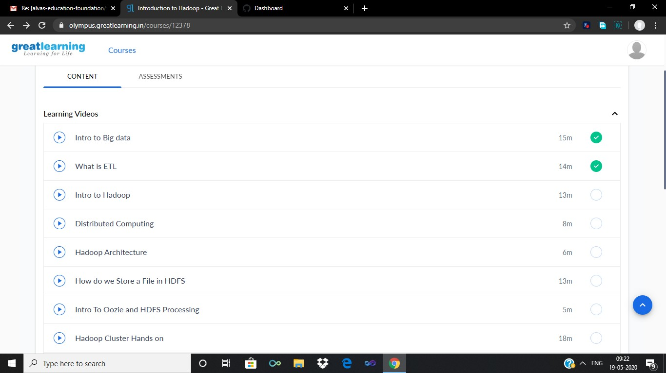

# What is ETL?

**ETL** is short for extract, transform, load, three database functions that are combined into one tool to pull data out of one database and place it into another database. Extract is the process of reading data from a database. Transformation occurs by using rules or lookup tables or by combining the data with other data.

# Why ETL important

Businesses have relied on the ETL process for many years to get a consolidated view of the data that drives better business decisions. Today, this method of integrating data from multiple systems and sources is still a core component of an organization’s data integration toolbox.

* When used with an enterprise data warehouse (data at rest), ETL provides deep historical context for the business.
* By providing a consolidated view, ETL makes it easier for business users to analyze and report on data relevant to their initiatives.
* ETL can improve data professionals’ productivity because it codifies and reuses processes that move data without requiring technical skills to write code or scripts.
* ETL has evolved over time to support emerging integration requirements for things like streaming data.
* Organizations need both ETL and ELT to bring data together, maintain accuracy and provide the auditing typically required for data warehousing, reporting and [analytics](https://www.sas.com/en_us/insights/analytics/what-is-analytics.html).

# Coding Challenges Details

Program no:1

package shortestpalindromeexample.java; import java.util.Scanner;

public class ShortestPalindromeDemo {

public static String shortestPalindrome(String str) { int x=0;

int y=str.length()-1;

while(y>=0){ if(str.charAt(x)==str.charAt(y)){ x++;

}

y--;

}

if(x==str.length()) return str;

String suffix = str.substring(x);

String prefix = new StringBuilder(suffix).reverse().toString(); String mid = shortestPalindrome(str.substring(0, x));

return prefix+mid+suffix;

}

public static void main(String[] args) { Scanner in = new Scanner(System.in);

System.out.println("Enter a String to find out shortest palindrome"); String str=in.nextLine();

System.out.println("Shortest palindrome of "+str+" is "+shortestPalindrome(str));

}

Program no:2

import java.util.Stack; class Node {

int data;

Node next;

Node(int i)

{

this.data = i; this.next = null;

}

};

class Main

{

// Function to determine if a given linked list is palindrome or not public static boolean isPalindrome(Node head)

{

// construct an empty stack Stack s = new Stack<>();

// push all elements of the linked list into the stack Node node = head;

while (node != null) { s.push(node.data); node = node.next;

}

// traverse the linked list again node = head;

while (node != null)

{

// pop the top element from the stack int top = s.pop();

// compare the popped element with current node's data

// return false if mismatch happens if (top != node.data) {

return false;

}

// advance to the next node node = node.next;

}

// we reach here only when the linked list is palindrome return true;

}

public static void main(String[] args)

{

Node head = new Node(1); head.next = new Node(2); head.next.next = new Node(3); head.next.next.next = new Node(2);

head.next.next.next.next = new Node(1);

if (isPalindrome(head)) { System.out.print("Linked List is a palindrome.");

} else {

System.out.print("Linked List is not a palindrome.");

}

}

}

}

}

}